EXPERIMENT 25
Create a new GitHub repository for a personal project. Initialize the repository with a README.md file. Then, clone the repository to your local machine, make some changes to the README.md (e.g., add a project description), and push the changes back to GitHub.
Tasks:
- Create a GitHub repository.
- Clone the repository to your local machine.
- Edit the README.md file.
- Stage, commit, and push your changes to GitHub.
Step 1: Created a new GitHub repository named my-project.
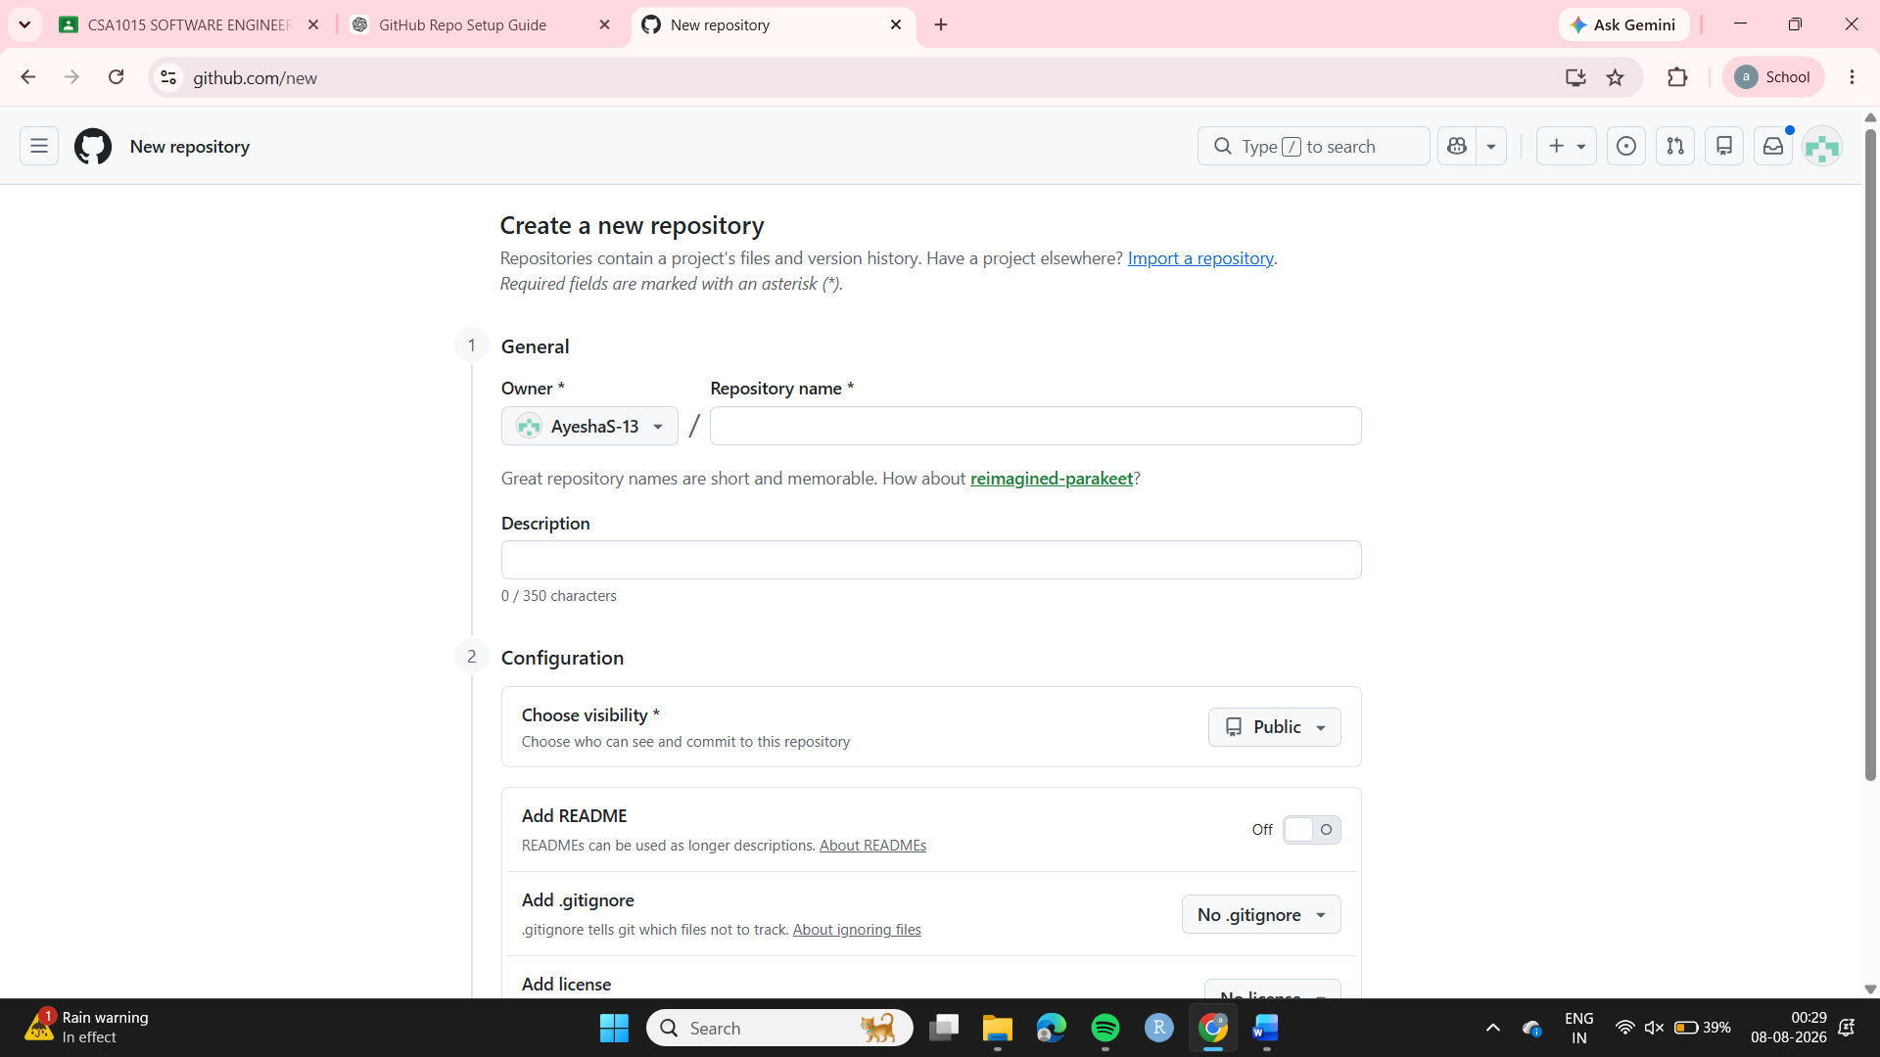
Step 2: Initialized the repository with a README.md file.
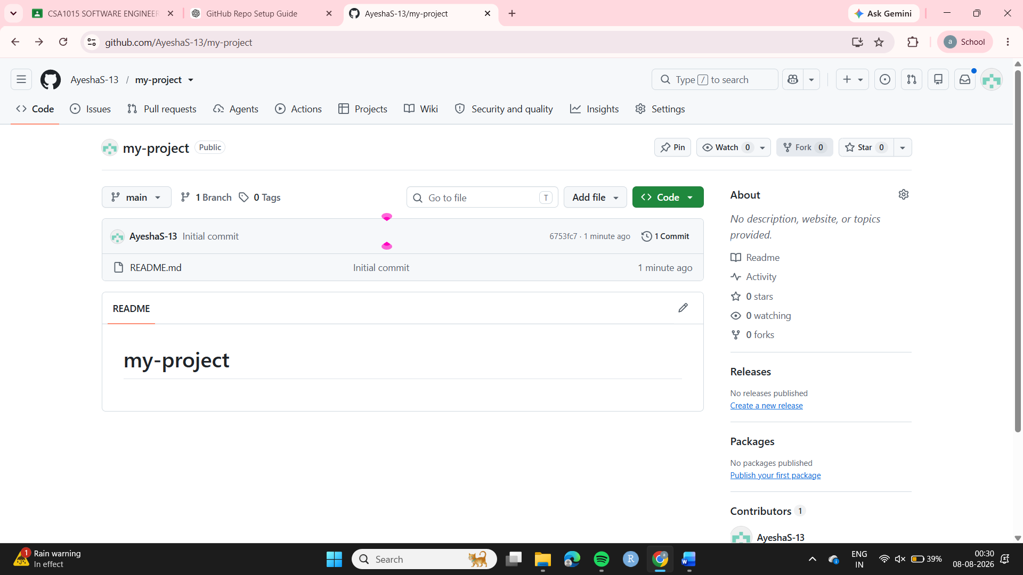
Step 3: Cloned the repository to the local machine using:
git clone https://github.com/AyeshaS-13/my-project
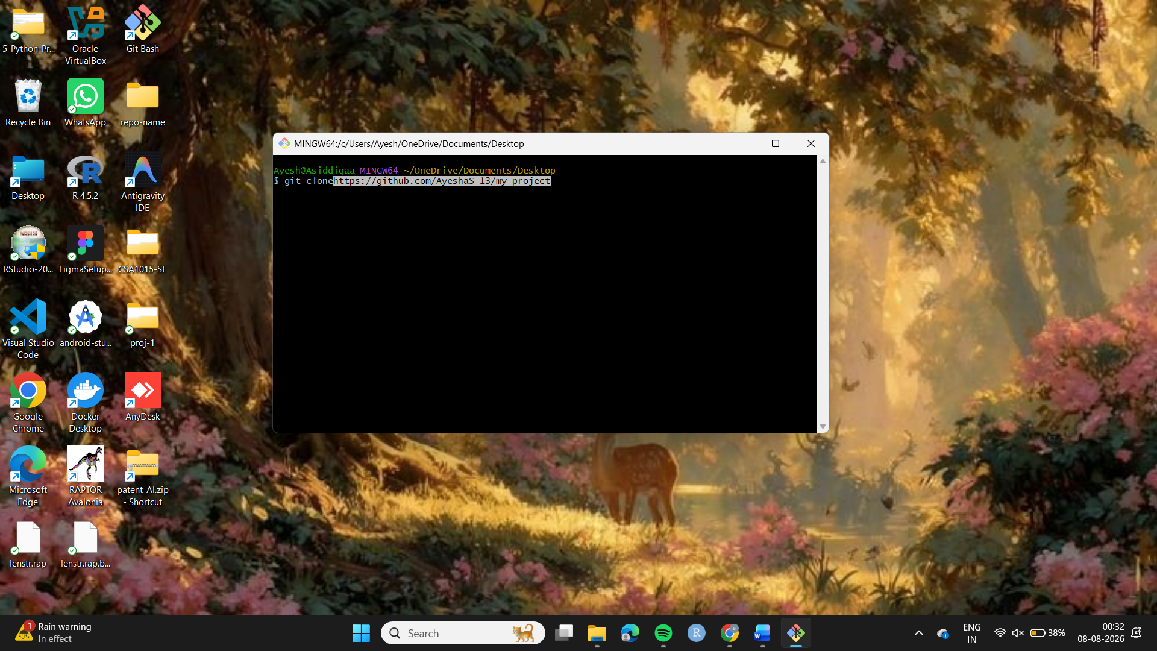
Step 4: Navigated into the repository:
cd my-project

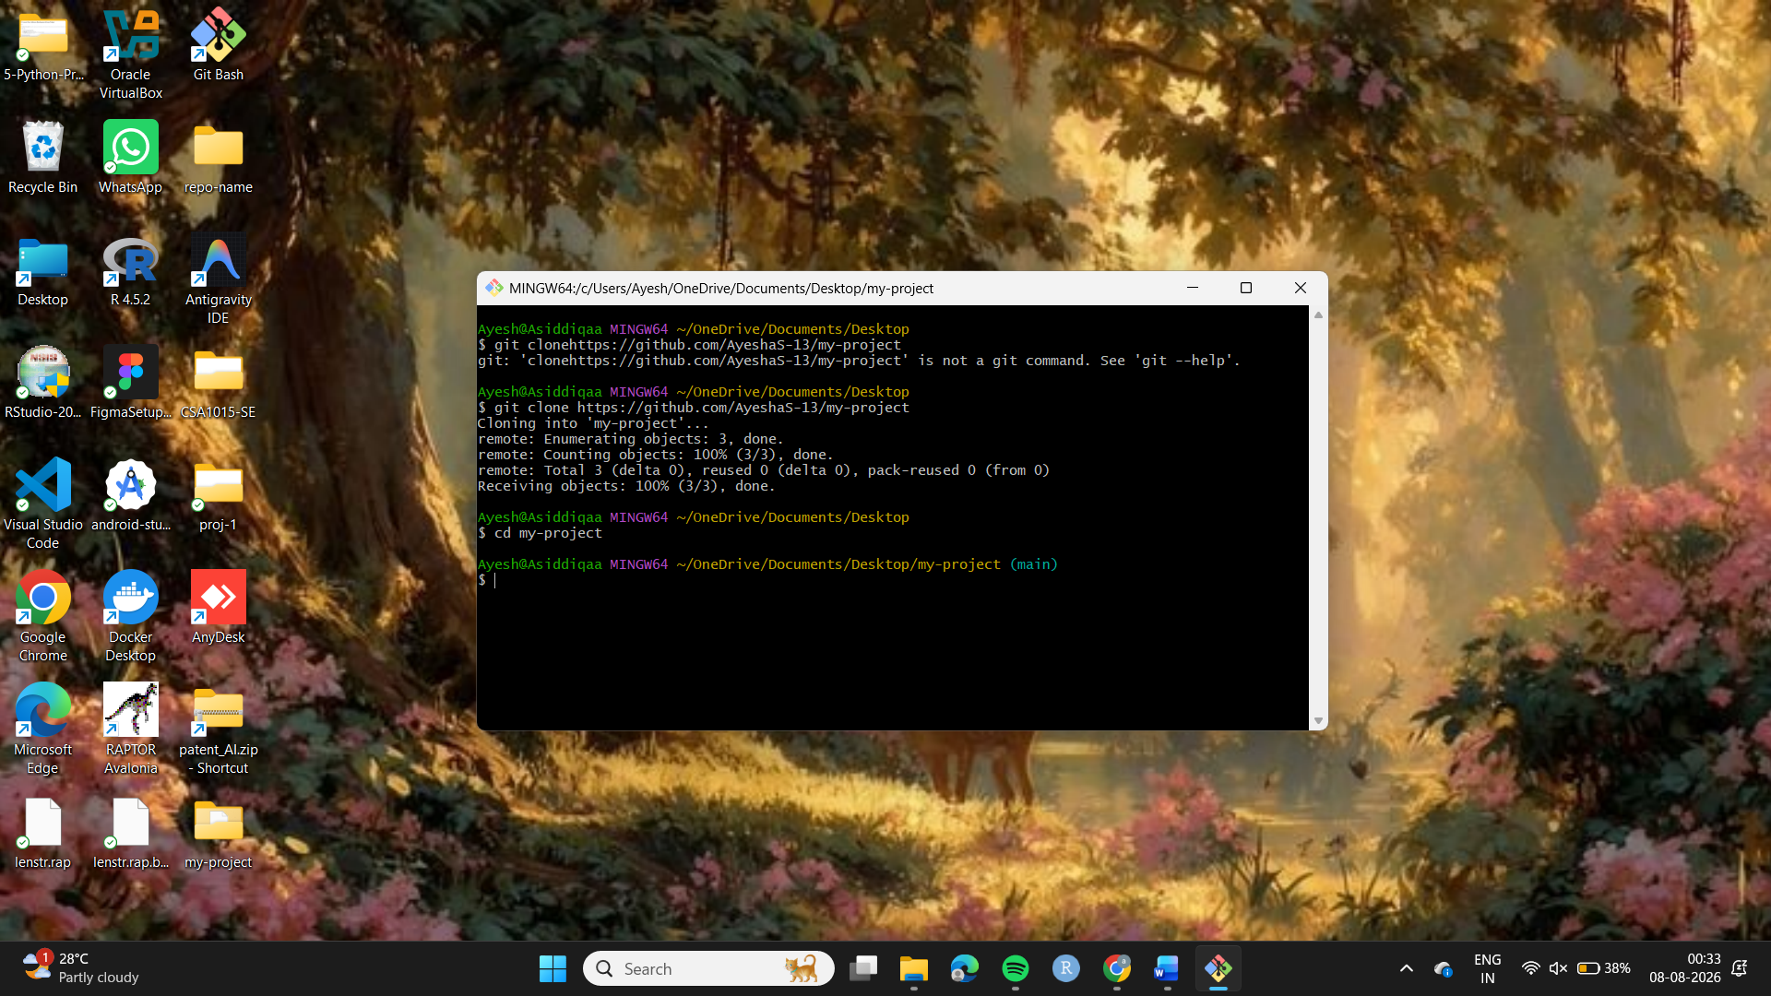
Step 5: Edited README.md and added the project title and description.
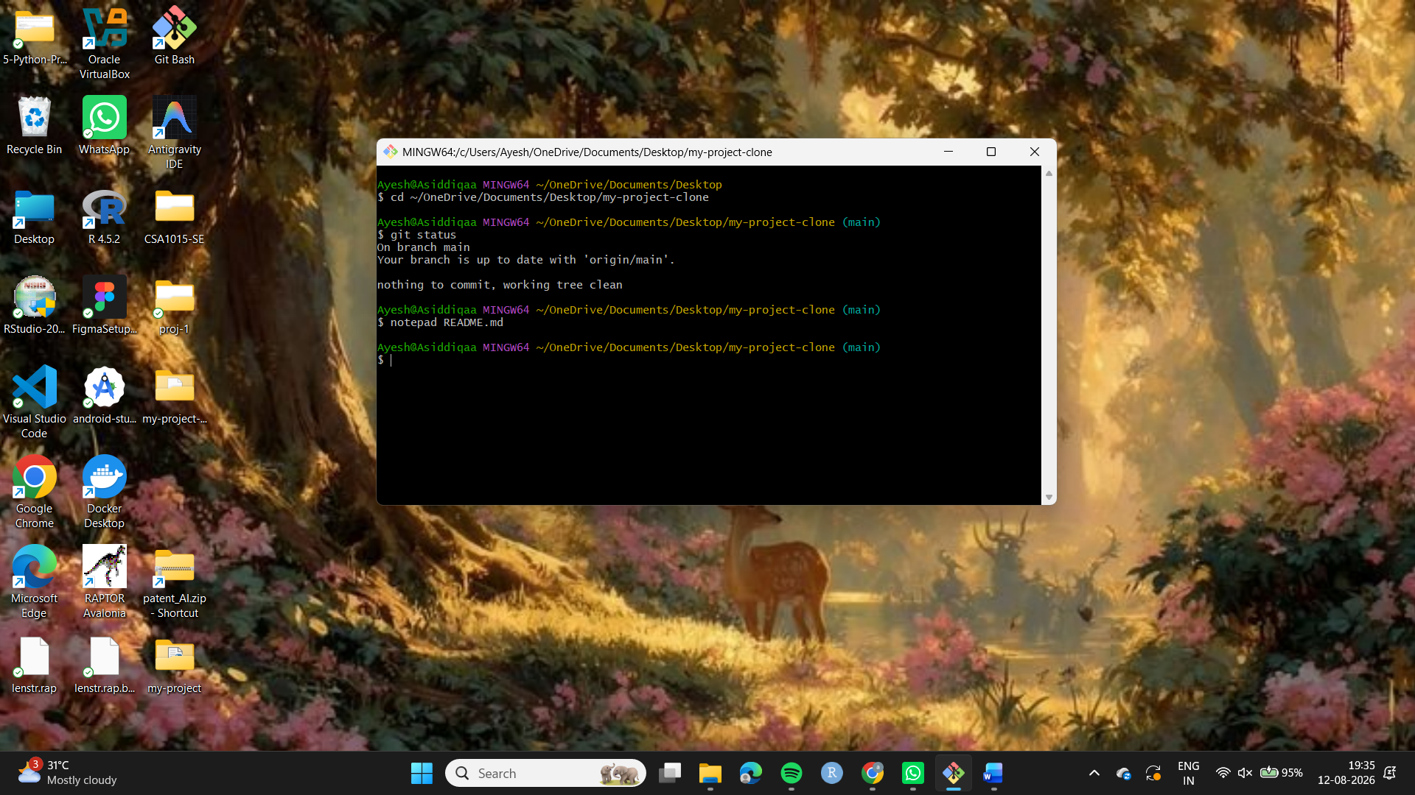
Step 6: Checked the modified files using:
git status
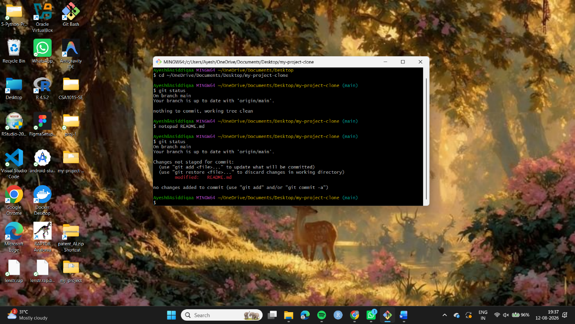
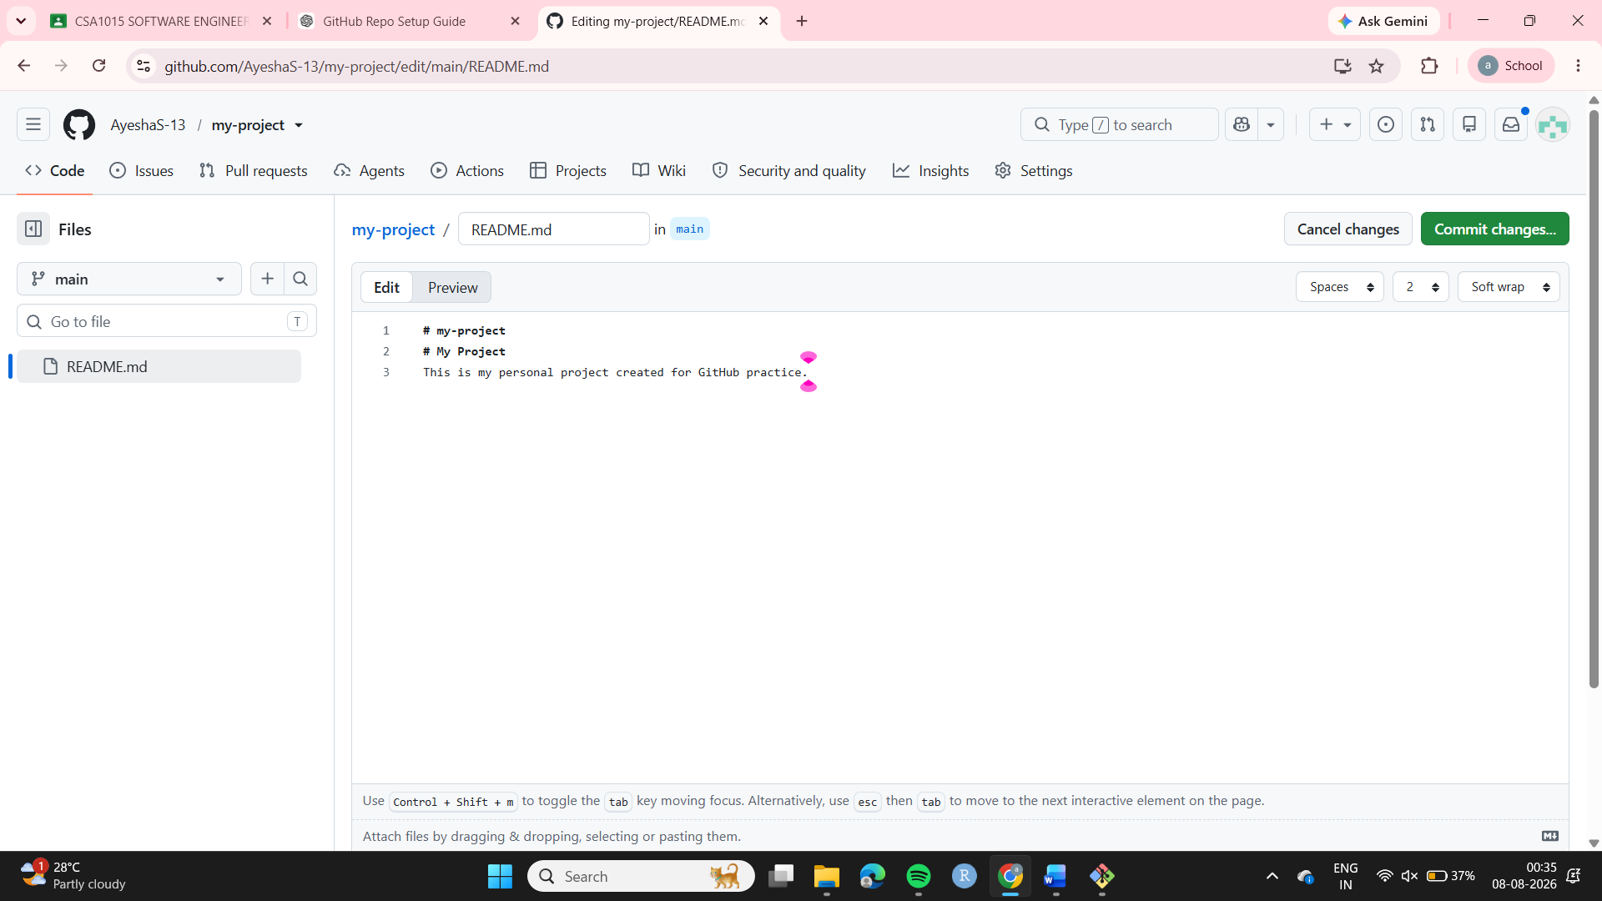
Step 9: Pushed the changes to GitHub:
git push origin main
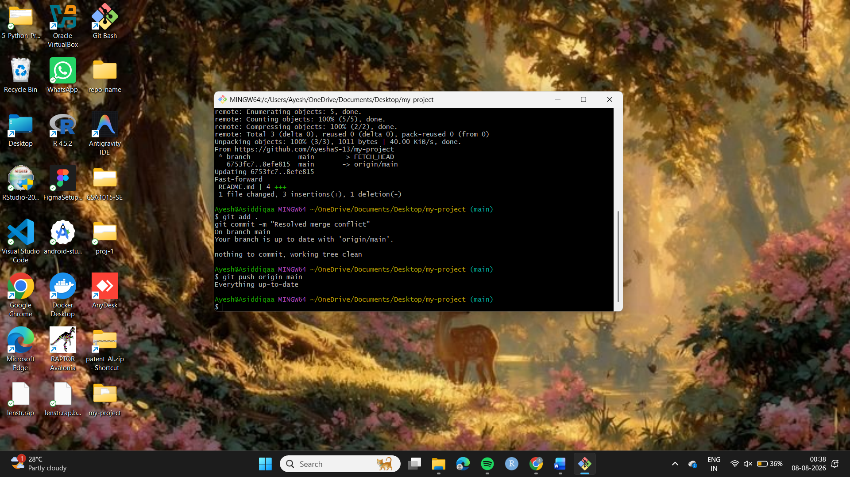
Step 11:Pull the Merged Changes to Local Machine.
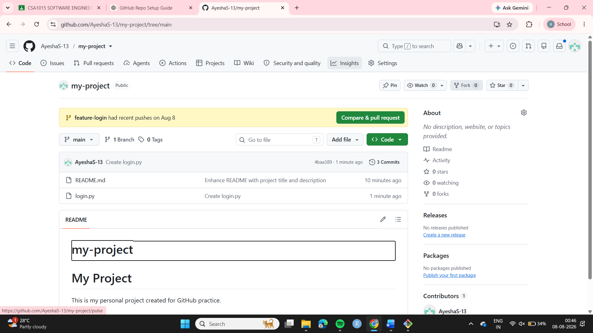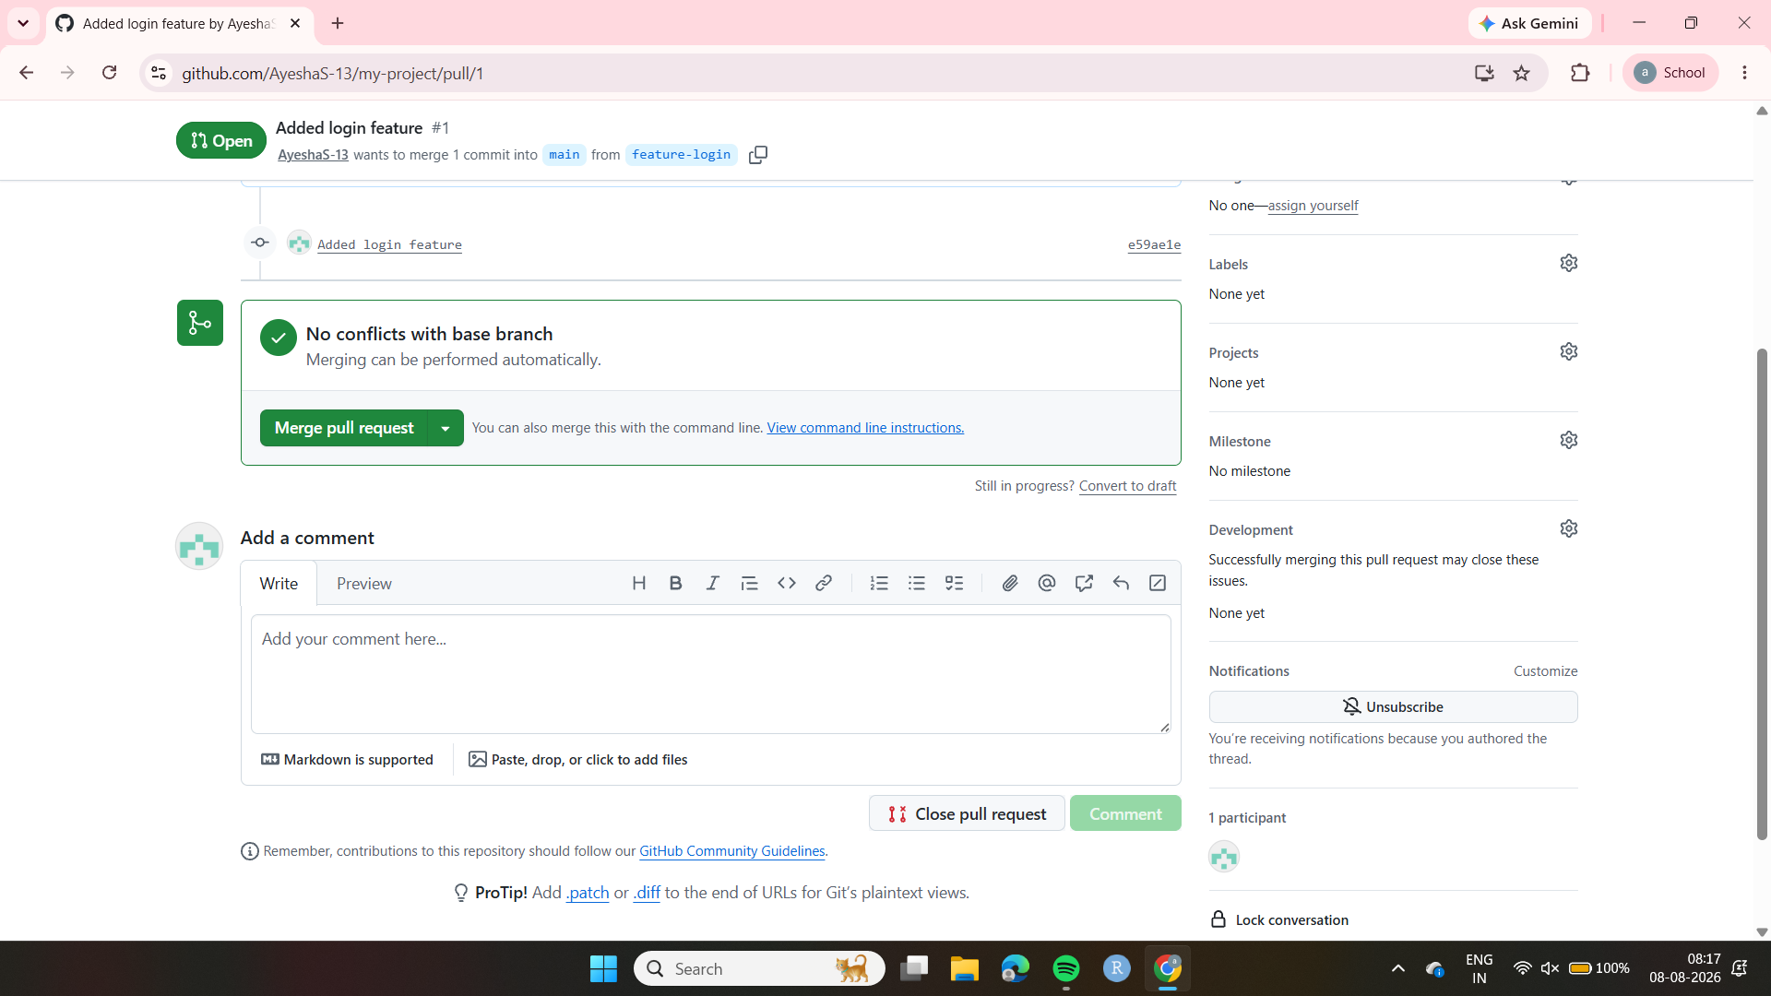
Result:-Pushed changes to Github Successfully.
